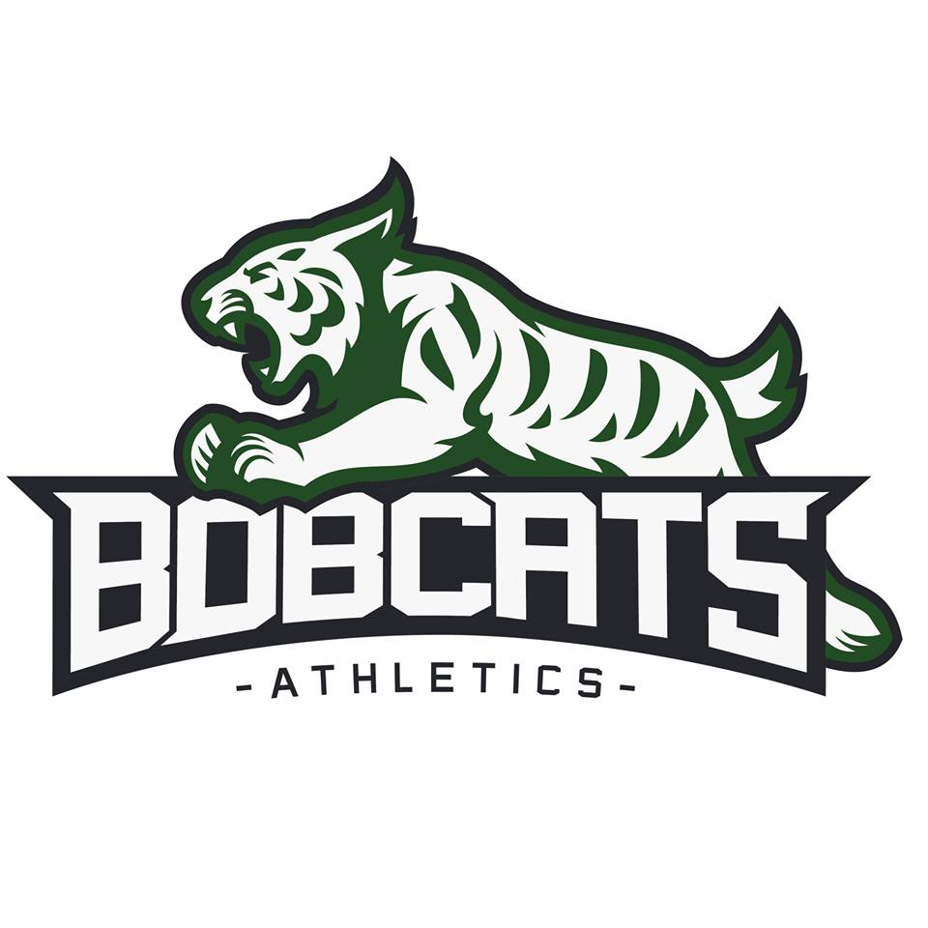
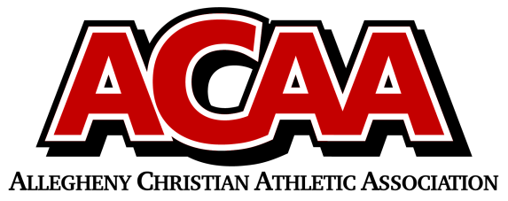
Official league roster - Soccer

School Name: Blair County Christian
Team Colors: Green/White
Overall Wins ___ Losses ____ Ties ___
Number | Name | Year | Position | Homeschool
14 | Melanie Gross | Sr. | Midfield
1 | Lydia Hileman | Sr. | Goalkeeper
10 | Anna Yingling | Sr. | Defense
7 | Gabriella Dull | Jr. | Forward/Midfield
21 | Abbie Lang | Jr. | Defense
6 | Macayla Hughes | Soph. | Midfield
4 | Jena Kane | Fresh. | Mid/Defense
8 | Johanna Love | Fresh. | Defense
13 | Rylie Oldham | Fresh. | Defense
3 | Ava Snyder | Fresh. | Midfield
16 | Kadee Spinazzola | Fresh. | Forward
2 | Alexa Hall | 8th | Midfield
11 | Calee Kennedy | 8th | Midfield
22 | Allison Hall | 7th | Midfield
23 | Hosanna Lang | 7th | Defense
18 | Gianna Spinazzola | 7th | Forward

Head Coach: Kari Dull
Asst. coach: Chris Davis
ACAA Wins ___ Losses ____ Ties ___

Official ACAA League Team Roster. to be submitted to the scorer’s table before each game.

